Documentation for client

Report 1: Filled map
The given data to the organization is belongs to 2 continents They are :
- North America
- Europe

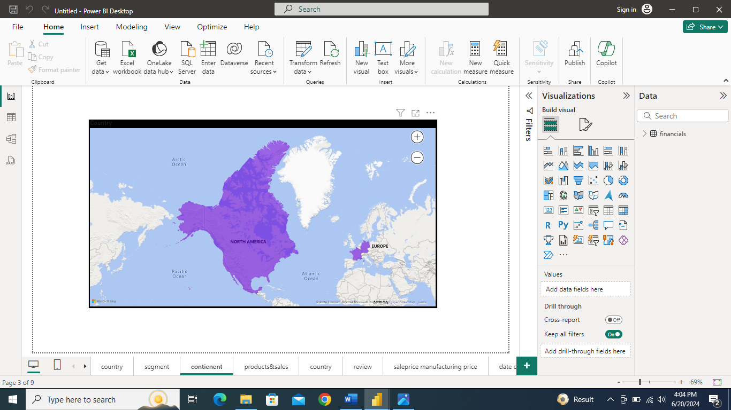

Report 2: Normal map
In the data that representing 5 countries they are
- North America
- Mexico
- Canada
- France
- Germany

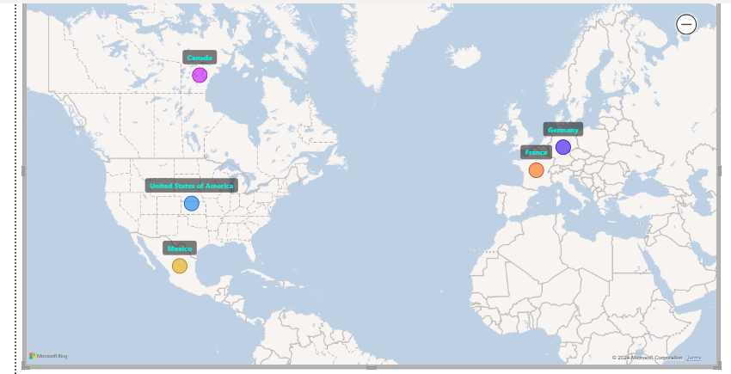

Report 3: funnel chart
The sales data which is received by the organization is having 5 different types of sectors
- Government
- Small Business
- Enterprise
- Midmarket
- Chanell partners

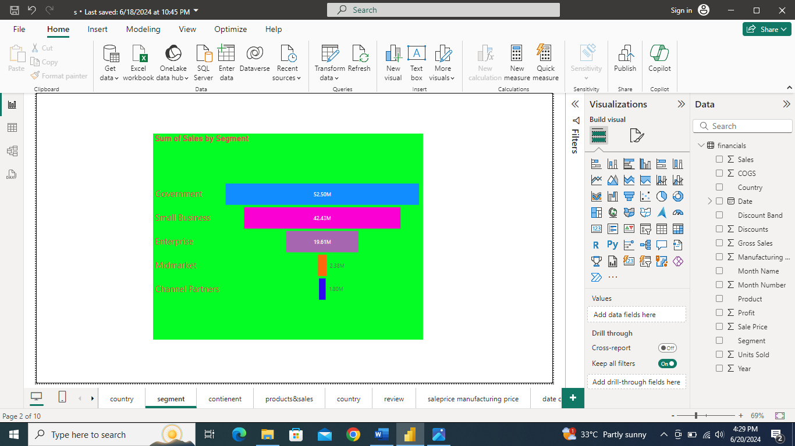
- The government sector having more sales and
- Channel partners having low sales in above information

Report 4: Stacked column chart
It represents the sales information of each products which are mentioned in the sales data

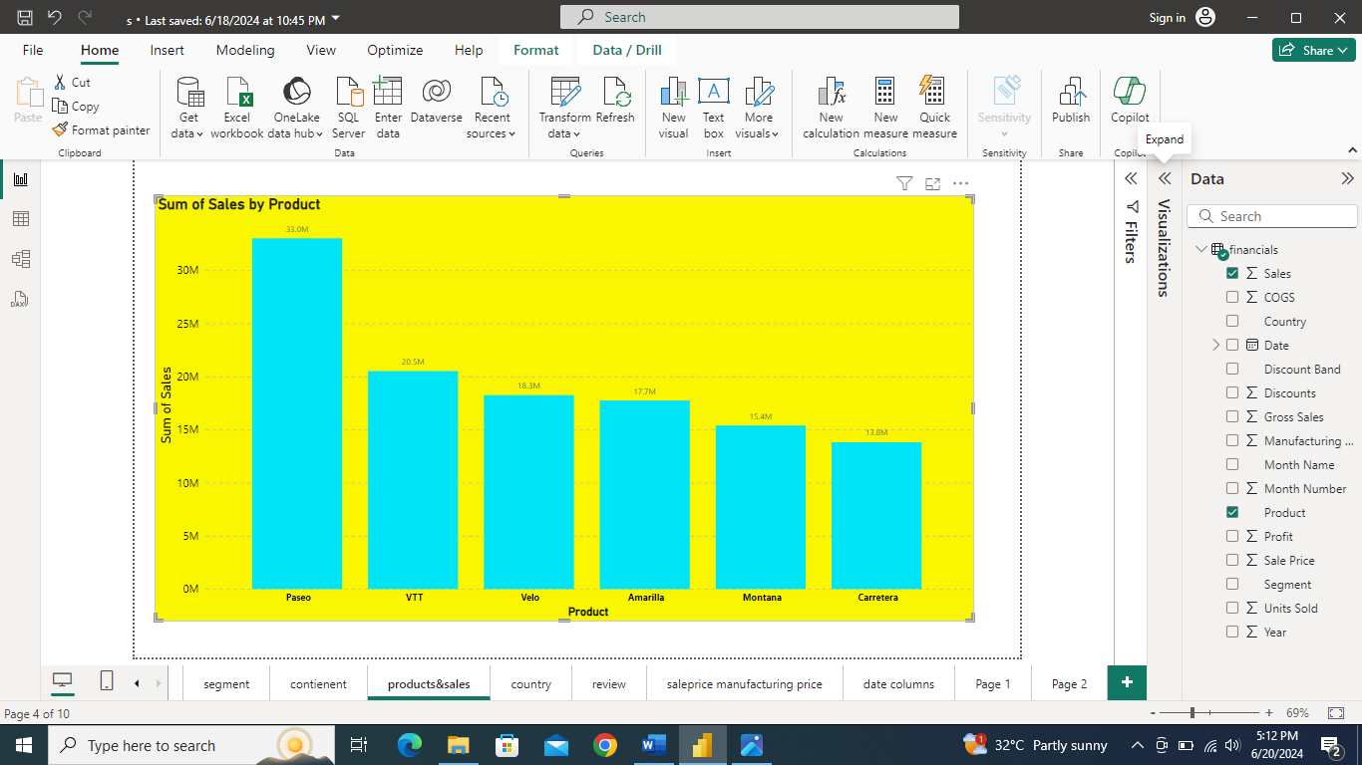
- the product Paseo having a very high sales then
1. VTT
2.Velo
3.Amarilla
4.Montana
5.Carretera
- and the Carretera having low sales according to above column chart

Report 5: Area chart
It Shows the products demand based on Discount bands
- High
- Low
- Medium
- None

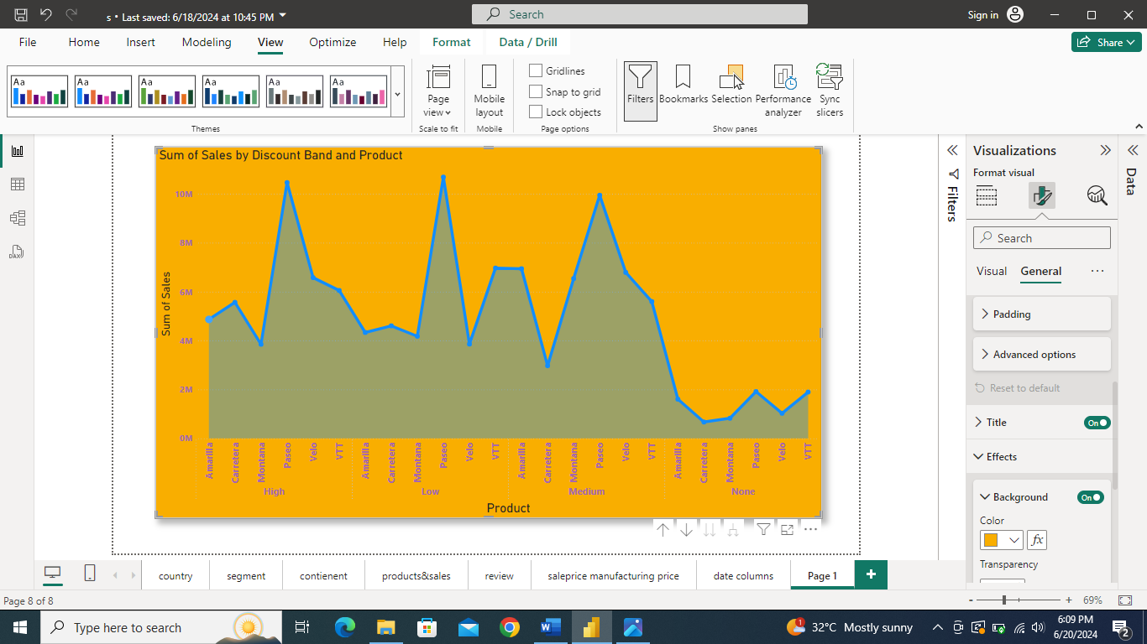
- When the discount band is in high range there is more sales for the product paseo and low sales is Montana
- When the products are with the low discount band then also the paseo is high sales and velo is low
- When discount band is medium the paseo is high and Carretera is low
- In none range of discount band is having high sale with paseo and low sale with Carretera

Report 6: Donut chart
The below Donut chart represents The quantity of units sold by product wise

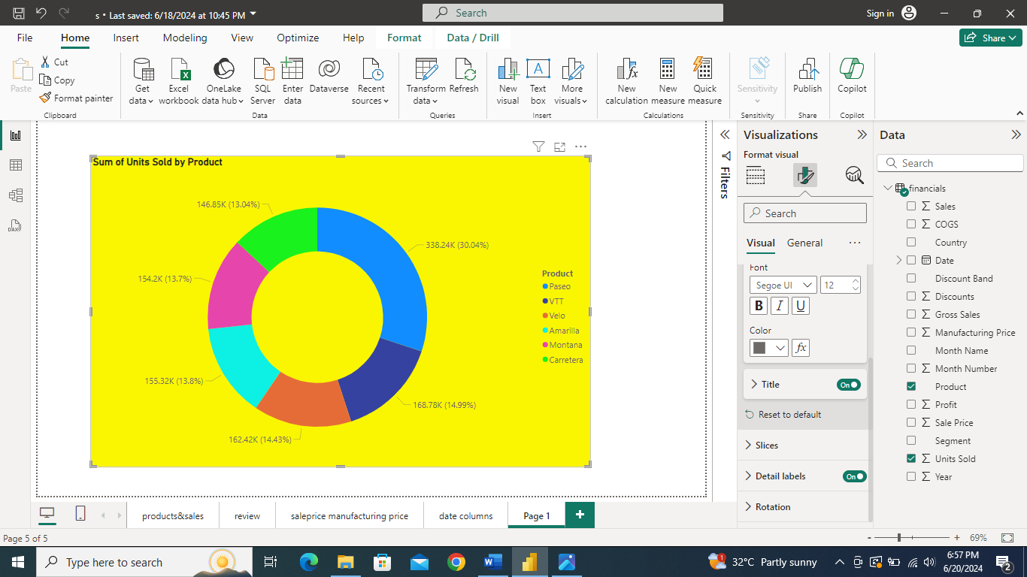

- As I mentioned that in above chart that the product paseo is sold high units according to the data considering with all products

Report 7: Cluster column chart

It is all about the manufacturing price and selling price of goods according to years 2013 and 2014 of goods

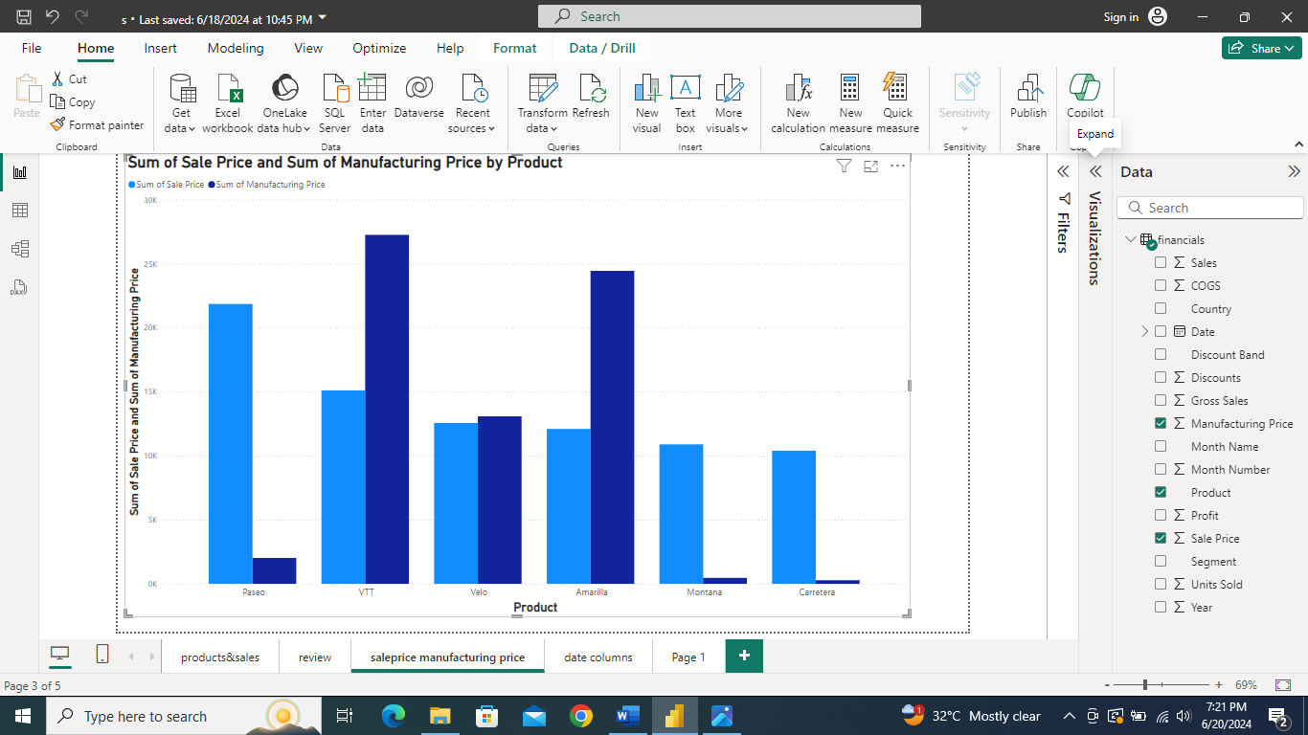

- When the manufacturing price is high of products VTT , Velo ,Amarilla and selling price is maintaining low ratio then it leads to the loss

- But , when manufacturing products Paseo, and Montana , Carretera and selling it for high price it makes u to get profit

Report 8: Pie chart
This is about the profit on goods sold according to the sales data which is recived by organisation

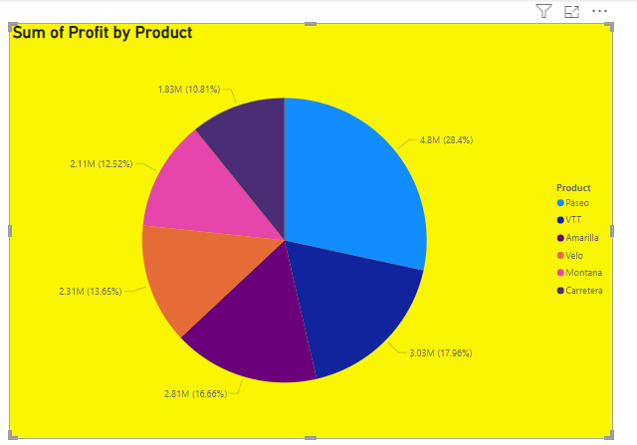

- The organization is earning more profits in selling the paseo

- And low profits on Carretera is mentioned in the above pie chart

- VTT, Amarilla, Velo, Montana are gaining average profits

Report 9: slicer and Area chart
Hear it contains the Presentation of profit by
- Year 2013 and 2014
- Quarters
- Months
- Days

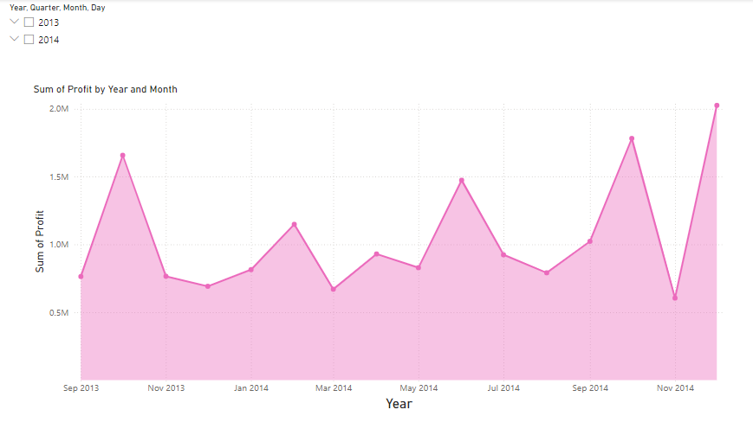
In the above chart shows the status of profit by year ,Quarter, month ,Day

REPORT 10: Slicer and area chart
Hear is the Presentation of sales by
- Year 2013 and 2014
- Quarters
- Months
- Days

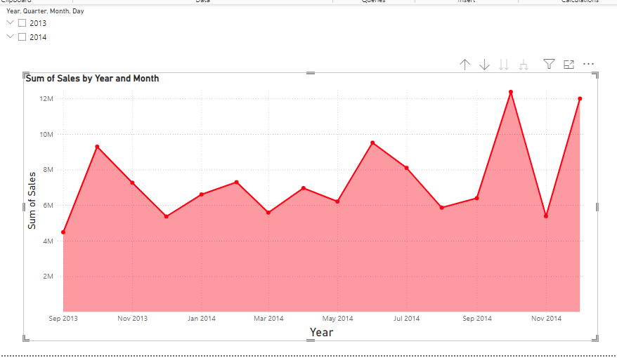
It represents the clear information about sales by Year , Quarter , Month , Day

Report 11: stacked column chart
In the below information is about the each product sales in each country

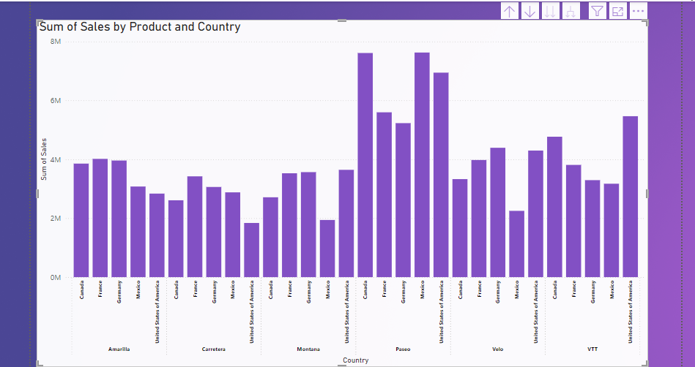

SUGGESTIONS :
- Please make selling to the product paseo in the every country for building profits to your Organization
- Don’t purchase the Carretera to the stores of United states of America and Montana to Mexico
- According to 2013 the sales are good in 2014 so, manufacture products with low price and sale it with high price
- The government sector is selling more products and the channel partners are low in selling so , don’t purchase goods

